

A
Project Report
on
A Comprehensive Examination of Machine Learning Models in Predicting 16 Personality Traits
submitted as partial fulfillment for the award of
BACHELOR OF TECHNOLOGY
DEGREE
SESSION 2023-24
in
Computer Science Engineering
By
Aroma Khan (2000290100029)
Harshit Menaria (2000290110074)
Ashish Kumar (2000290130048)
Under the supervision of
Dr Preeti Garg
KIET Group of Institutions, Ghaziabad
Affiliated to
Dr. A.P.J. Abdul Kalam Technical University, Lucknow
(Formerly UPTU)
April, 2024

DECLARATION
We hereby declare that this submission is our own work and that, to the best of our knowledge and belief, it contains no material previously published or written by another person nor material which to a substantial extent has been accepted for the award of any other degree or diploma of the university or other institute of higher learning, except where due acknowledgment has been made in the text.

Signature
Name: Aroma Khan
Roll No.: 2000290100029
Date:29 April,2024

CERTIFICATE

This is to certify that Project Report entitled “A Comprehensive Examination of Machine Learning Models in Predicting 16 Personality Traits” which is submitted by Aroma Khan in partial fulfillment of the requirement for the award of degree B. Tech. in Department of Computer Science & Engineering of Dr. A.P.J. Abdul Kalam Technical University, Lucknow is a record of the candidates own work carried out by them under my supervision. The matter embodied in this report is original and has not been submitted for the award of any other degree.
.

Supervisor Name Dr. Preeti Garg
(Designation) (Asst. Professor)

Date:29/04/24

ACKNOWLEDGEMENT

It gives us a great sense of pleasure to present the report of the B. Tech Project undertaken during B. Tech. Final Year. We owe special debt of gratitude to superisor name, Department of Computer Science & Engineering, KIET, Ghaziabad, for his constant support and guidance throughout the course of our work. His sincerity, thoroughness and perseverance have been a constant source of inspiration for us. It is only his cognizant efforts that our endeavors have seen light of the day.
We also take the opportunity to acknowledge the contribution of Dr. Vineet Sharma, Head of the Department of Computer Science & Engineering, KIET, Ghaziabad, for his full support and assistance during the development of the project. We also do not like to miss the opportunity to acknowledge the contribution of all the faculty members of the department for their kind assistance and cooperation during the development of our project.
We also do not like to miss the opportunity to acknowledge the contribution of all faculty members, especially faculty/industry person/any person, of the department for their kind assistance and cooperation during the development of our project. Last but not the least, we acknowledge our friends for their contribution in the completion of the project.
Date: 29-04-24
Signature:
Name : Aroma Khan
Roll No.: 2000290100029

ABSTRACT
This study explored the field of machine learning as it relates to personality trait prediction using the widely used psychological assessment tool, the Myers-Briggs Type Indicator (MBTI). The study used a variety of machine learning frameworks to successfully complete this objective. The used dataset included self-identification data in addition to demographic information, offering a thorough foundation for research. Preprocessing procedures were carried out to turn categorical characteristics like gender into numerical values, making the data appropriate for machine learning methods and facilitating easier model processing.
The multinomial classification challenge given by the 16 personality qualities of the MBTI led to the development of multinomial logistic regression as a popular technique. The model made use of variables related to these personality traits, including age, gender, and recall scores. The Newton-CG solver was utilized to optimize the model parameters with the goal of improving accuracy and guaranteeing convergence. The 16 MBTI personality traits and testing data from demographic data sources were used to validate the constructed model's effectiveness. Through this validation approach, the prediction power and generalizability of the model to new data were assessed.
This study's main objective was to measure each participant's unique personality traits and provide the findings in an accessible format. The researchers sought to offer insights into human behavior and preferences in a variety of sectors, including emotions, human resources, and tailored suggestions, by utilizing machine learning approaches.The study's findings demonstrated how well logistic regression works with the MBTI 16 personality types to predict personality traits accurately. Additionally, the results showed how machine learning can be used to identify trends in human behavior and preferences, providing insightful information that can be applied to a variety of fields. Through the lens of data-driven approaches, this study advances our understanding of human psychology and behavior and opens up new possibilities for creative applications in fields like human resource management and personalized suggestions.

TABLE OF CONTENTS |  | Page No.
DECLARATION……………………………………………………………………. |  | ii
CERTIFICATE……………………………………………………………………… |  | iii
ACKNOWLEDGEMENTS…………………………………………………………. |  | iv
ABSTRACT………………………………………………………………………..... |  | v
LIST OF FIGURES…………………………………………………………………. |  | ix
LIST OF TABLES…………………………………………………………………… |  | xi
LIST OF ABBREVIATIONS………………………………………………………. |  | xii
CHAPTER 1 (INTRODUCTION)…………………………………………………. |  | 1
1.1. Introduction……………………………………………………………………... |  | 1
1.2. Project Description……………………………………………………………… |  | 1
CHAPTER 2 (LITERATURE RIVIEW)…………………………………………. |  | 2
CHAPTER 3 (PROPOSED METHODOLOGY) ….................................................. |  | 3
CHAPTER 7 (CONCLUSIONS AND FUTURE SCOPE).................................. |  | 5
REFERENCES………………………………………………………………………. |  | 6
APPENDEX………………………………………………………………………... |  | 7
LIST OF FIGURES
Figure No. | Description | Page No.
1. | Classification using Multinomial Naïve Bayes. | 18
2. | Classification using random forest | 19
3. | Classification using LightGBM | 20
4. | Classification using Logistic Regression | 21
5. | Comparative analysis of Precision score | 22

LIST OF TABLES
Table. No. | Description | Page No.
1. | 16 Personality Traits | 10
2. | Precision Score Table | 21
3. | Accuracy Value Table | 23
4. | Precision Value Table | 24
5. | F1-Score Table | 24
6. | Recall Table | 25
7. | Comparative Analysis Table | 25

LIST OF ABBREVIATIONS
S.N. | TYPE | ABBR. | DESCRIPTION
1. | ISTJ | The Inspector | tactful and sensible, devoted, tidy, and conventional.
2. | ISTP | The Crafter | Extremely autonomous and eager to learn firsthand from different experiences.
3. | ISFJ | The Protector | kind and committed, ever prepared to defend those they love.
4. | ISFP | The Artist | calm and adaptable, taciturn and creative.
5. | INFJ | The Advocate | Analytical and creative, one of the rarest kinds.
6. | INFP | The Mediator | High-minded and idealistic, they work to improve the world.
7. | INTJ | The Architect | extremely rational, imaginative, and analytical.
8. | INTP | The Thinker | renowned for having a vibrant inner life; quiet and introverted.
9. | ESTP | The Persuader | extroverted, theatrical, and appreciative of the moment.
10. | ESTJ | The Director | tenacious, rule-abiding, idealistic, and prone to taking the lead.
11. | ESFP | The performer | gregarious, impulsive, and loves the limelight.
12. | ESFJ | The Caregiver | extroverted and kind, with a propensity to see the best in people.
13. | ENFP | The Champion | vivacious and captivating, flourishes in imaginative environments.
14. | ENFJ | The Giver | Sensitive and devoted, well-known for compassion and giving.
15. | ENTP | The Debater | Extremely creative, enjoys being surrounded by ideas, yet sometimes find it difficult to complete tasks.
16. | ENTJ | The Commander | Outgoing, self-assured, and exceptionally skilled at planning and project management.

CHAPTER 1
INTRODUCTION

1.1 INTRODUCTION
It's common practice to determine someone's personality based on their nature. These were formerly completed manually, which took a long time to determine the person's personality. Businesses that prioritize their customers, including those in retail, finance, communications, and marketing, are the ones who employ data mining the most frequently these days. The data was analyzed using a variety of methods, including surveys, questionnaires, interviews, classroom exercises, data from social media networks and retail websites on user experiences and challenges. On the other hand, traditional methods are scale- and time-limited. The user's personality will be made clear by our suggested technology. Determining an individual's nature to determine their personality is not a novel concept. The way a person interacts with the outside world and their environment can also be influenced by their personality. Among other things, personality may be utilized as a differentiator in career counseling, health counseling, and hiring processes. It's common practice to analyze a person's behavior to infer their personality. It required a lot of time and work to forecast personalities manually [1].
No personality type is "better" or "best" than any other. Some of the personality types are explained here.

Introversion (I) and Extraversion (E):

The extraversion-introversion dichotomy explains human behavior and interactions with the outside world. In contrast to introverts, who value thoughtful conversations, feel refreshed after spending time alone, and enjoy in-depth, meaningful dialogues, Extroverts enjoy frequent social interactions, are goal-oriented, and experience a boost in energy after interacting with others. All of us display some extraversion or introversion, although most individuals lean more toward one or the other overall.

Sensing (S) – Intuition (N)-

Individuals spend time feeling and intuiting depending on the environment, much like extraverts and introverts do. While individuals who value intuition pay attention to perceptions and patterns, those who value sensing concentrate on reality and get knowledge from their senses. Those who favor sensing concentrate on facts and practical experiences, whereas they like to imagine possibilities and abstract ideas.

Thinking(T) – Intuition(N) –

Reasoning people are more likely to regard facts and unbiased information. When making a choice, they are usually dispassionate, rational, and consistent. When making decisions, those who value feeling are more inclined to take other people and their feelings into account.

Judging (J) – Perceiving (P)-

Judging-inclined people like structure and decisive outcomes. Individuals with a tendency for perception are more receptive, adaptive, and flexible. The other scales are impacted by these two inclinations.

1.2 PROJECT DESCRIPTION
With a focus on employing a LightGBM since it performs better than the other three models—Random forest, Multinomial Naive Bayes, and Logistic Regression—this study examines the possible uses of machine learning to personality prediction models. The model
uses a collection of retrieved relevant parameters to predict personality traits. The approach consists of four steps: data preparation, feature selection, model training, and assessment. To translate the categorical personality labels into a machine learning algorithm-understandable format, we employ techniques such as label encoding. In addition, we separated the dataset into training and testing sets to guarantee the model's performance for generalization.

Table 2: 16 Personality Traits
S.N. | TYPE | ABBR. | DESCRIPTION
1. | ISTJ | The Inspector | tactful and sensible, devoted, tidy, and conventional.
2. | ISTP | The Crafter | Extremely autonomous and eager to learn firsthand from different experiences.
3. | ISFJ | The Protector | kind and committed, ever prepared to defend those they love.
4. | ISFP | The Artist | calm and adaptable, taciturn and creative.
5. | INFJ | The Advocate | Analytical and creative, one of the rarest kinds.
6. | INFP | The Mediator | High-minded and idealistic, they work to improve the world.
7. | INTJ | The Architect | extremely rational, imaginative, and analytical.
8. | INTP | The Thinker | renowned for having a vibrant inner life; quiet and introverted.
9. | ESTP | The Persuader | extroverted, theatrical, and appreciative of the moment.
10. | ESTJ | The Director | tenacious, rule-abiding, idealistic, and prone to taking the lead.
11. | ESFP | The performer | gregarious, impulsive, and loves the limelight.
12. | ESFJ | The Caregiver | extroverted and kind, with a propensity to see the best in people.
13. | ENFP | The Champion | vivacious and captivating, flourishes in imaginative environments.
14. | ENFJ | The Giver | Sensitive and devoted, well-known for compassion and giving.
15. | ENTP | The Debater | Extremely creative, enjoys being surrounded by ideas, yet sometimes find it difficult to complete tasks.
16. | ENTJ | The Commander | Outgoing, self-assured, and exceptionally skilled at planning and project management.

CHAPTER 2
LITERATURE REVIEW
A number of researchers have worked in the field of personality prediction using various Machine Learning techniques. [1] aims to predict personality using social media applications. The technique employed is Pearson Correlation, where a novel Binary-Partitioning Transformer (BPT) integrated with Term Frequency & Inverse Gravity Moment (TF-IGM) is utilized. This approach aims to forecast the impact of social media applications on human behavior and personality. The results achieved include an F1-score of 0.762 and an accuracy of 78.43%.
[2] focuses on improving detection of personality traits using various machine learning techniques including Decision Tree, Naïve Bayes, Random Forest, Support Vector Machine (SVM), and Neural Networks. The study aims to enhance driver assistance systems by evaluating physiological data obtained from healthy volunteers in hazardous urban environments. Results are presented for different personality traits, where Agreeableness achieves an accuracy of 92.3% and an F1-score of 91.8%, Conscientiousness achieves 90% accuracy and 89.2% F1-score, Extraversion achieves 90% accuracy and 89.8% F1-score, Neuroticism achieves 89.5% accuracy and 89.5% F1-score, and Openness achieves 89.8% accuracy and F1-score.
[3], personality prediction is conducted through handwriting analysis using the Big Five model architecture. Various machine learning models, namely Support Vector Machine (SVM), K-Nearest Neighbors (KNN), and Decision Tree, are employed for this purpose. The study aims to predict individuals' personalities based on their handwriting characteristics. Results indicate high accuracies for the different models: SVM achieves an accuracy above 90%, KNN achieves 88.6% accuracy, and Decision Tree achieves an accuracy above 99%. These findings suggest the effectiveness of utilizing handwriting analysis and machine learning techniques for personality prediction.
[4] addresses text-based personality prediction using a multi-model deep learning architecture combined with multiple pre-trained language models. With the vast user base of 3.8 billion active social media users, the system has significant implications for various domains such as personal recommendation systems, online marketing, and recruitment. The results indicate a mean accuracy of 77.34% and a mean F1-score of 0.749, underscoring the potential of the approach in accurately predicting personality traits based on text data.
[5] investigates personality prediction utilizing XG-Boost. The study focuses on predicting personality traits among Facebook users by leveraging social network architecture and elements of the Big Five model. The achieved accuracy stands at 74.2%, showcasing the potential of the approach in discerning personality traits based on Facebook user data.
[6] delves into product recommendation employing personality prediction techniques. The methodology involves interest mining, item mapping, discovering meta paths, and recommendation strategies. The resulting system, termed Meta-Interest, is designed as a personality-aware product recommendation system, particularly adept at enhancing accuracy and recall in cold-start scenarios. Notably, Meta-Interest achieves a precision of 0.854 and a recall of 0.868, while DGRec attains a precision of 0.845 and a recall of 0.855, further demonstrating the effectiveness of personality-based recommendation systems.
[7] explores personality prediction for electronic marketplaces using a Generalized Linear Model (GLM). The primary objective is to forecast user personality and discern product preferences based on individual personality traits. To achieve this, the study proposes a methodology for analyzing social media data. The results indicate a mean accuracy of 66.6% and a mean precision of 0.670, highlighting the potential of using personality prediction techniques to personalize recommendations and improve user satisfaction within electronic marketplaces.
[8] focuses on personality assessment within the field of psychology, employing the KGrAt-Net architecture. The study delves into the analysis of text-based Automatic Personality Prediction (APP) performance across various domains, with a specific emphasis on knowledge graph representation. Two variations of the KGrAt-Net architecture are explored: one utilizing Knowledge Graph Attention Network alone and another incorporating embeddings. Results reveal notable performance metrics for both approaches. The Knowledge Graph Attention Network achieves a precision of 64.82%, a recall of 81.44%, and an accuracy of 70.26%. On the other hand, the version with embeddings achieves enhanced performance, with a precision of 69.27%, a recall of 80.58%, and an accuracy of 72.41%. These findings underscore the efficacy of leveraging knowledge graph representation within the KGrAt-Net architecture for text-based personality prediction in psychology.

- Comparative Anaysis of state of art techniques
12 | Goal | Technique/  Algorithm | Description | Results
[1] | Personality prediction using social media applications. | Pearson Correlation | A novel Binary-Partitioning Transformer (BPT) equipped with Term Frequency & Inverse Gravity Moment (TF-IGM) is employed in this work to forecast social media applications' effects on human behavior and personality. | F1- score: 0.762  Accuracy: 78.43%
[2] | Personality traits for detection improvement | - Decision Tree  - Naïve Bayes  - Random Forest  - SVM  - Neural Networks | In order to enhance driver assistance systems, the study use machine learning to evaluate physiological data from healthy volunteers in hazardous urban environments. | 1.Agreeableness:  Accuracy:92.3%  F1-score: 91.8%  2.Conscientiousness:  Accuracy:90%  F1-score:89.2%  3.Extraversion:  Accuracy:90%  F1-score:89.8%  4.Neuroticism:  Accuracy:89.5%  F1-score:89.5%  5.Openness:  Accuracy:89.8%  F-score: 89.8%
[3] | Personality Prediction through Handwriting with Big Five model architecture. | - SVM  - KNN  - Decision Tree | The work predict the personality of the person using their handwriting and various Machine learning models are used here. | Accuracy:  1.SVM- above 90%  2.KNN- 88.6%  3.Decision Tree- above 99%
[4] | Text based Personality Prediction. | Multi model deep learning architecture and multiple pre-trained language models. | With 3.8 billion active social media users, personal recommendation systems, online marketing, and recruitment can all benefit from this system. | Mean Accuracy: 77.34%  Mean F1-score: 0.749
[5] | Personality Prediction | XG-Boost | This study examines the prediction of personality traits among Facebook users by utilizing social network architecture and Big 5 model elements. | Accuracy: 74.2%
[6] | Product recommendation using personality prediction. | - Interest Mining  - Item mapping  - Discover Meta Paths  - Recommend | Using interest mining and meta-path discovery, Meta-Interest is a personality-aware product recommendation system that enhances accuracy and recall in cold-start scenarios. | 1.Meta Interest:  Precision- 0.854  Recall- 0.868  2.DGRec:  Precision- 0.845  Recall- 0.855
[7] | Personality Prediction for electronic marketplace. | Generalized Linear model | In order to forecast user personality and determine product preferences based on personality, this article suggests a methodology for analyzing social media data. | Mean Accuracy: 66.6%  Mean Precision: 0.670
[8] | Personality assessment in psychology. | KGrAt-Net architecture. | This work investigates the use of KGrAt-Net, to the analysis of text-based Automatic Personality Prediction (APP) performance across domains, with an emphasis on knowledge graph representation. | 1.Knowledge Graph Attention Network:  Precision- 64.82%  Recall-81.44%  Accuracy-70.26%  2.Knowledge Graph Attention Network with EmbeddingsPrecision- 69.27%  Recall-80.58%  Accuracy-72.41%

CHAPTER 3
PROPOSED METHODOLOGY
A number of machine learning models as explained below are implemented to predict the personality of the individuals.

Multinomial Naïve Bayes:

Naive Bayes classifier is based on Bayes theorem [9]. Here A number of personality types have low precision, recall, and F1-scores; the accuracy on the training dataset is also rather low. This implies that the model might not be operating optimally with the available data. The classification results are shown in Figure 2. The X-Asis shows the 16 persoinality traits. The Figure shows that some classes had 0 accuracy, recall, or F1-score, suggesting that the model failed to classify examples of those classes properly. The model appears to have trouble making generalizations about certain personality types.
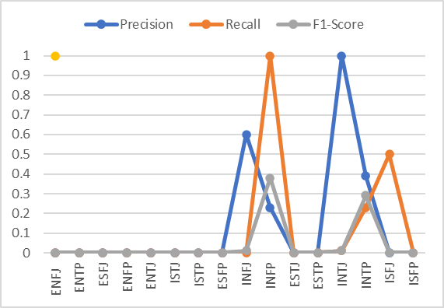
- Classification using Multinomial Naïve Bayes

Random Forest Classifier:

Random forest is a computationally efficient method of ensemble learning, categorized under homogeneous base learner category. Its structure offers two advantages: computationally, it can handle regression and classification issues at high speed, making it a fast classic classifier. Statistically, it has features like feature prioritization, weight attribution, and unsupervised learning ability, making it suitable for high-dimensional issues [10]. The classification results are shown in Figure 3. Compared to the Multinomial Naive Bayes model, the accuracy on the training dataset is greater; nonetheless, performance problems persist, particularly with respect to specific personality types. For several classes, the recall, F1-score, and accuracy are still quite poor.
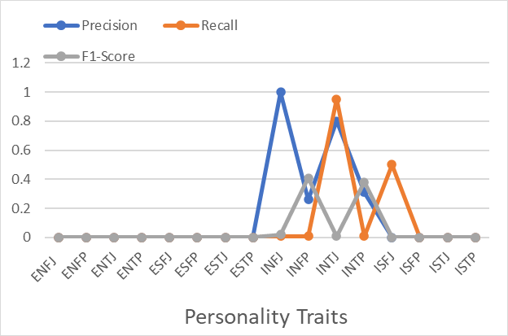
- Classification using random forest

LightGBM Classifier:

LightGBM is a gradient-boosting framework that uses decision trees to lower memory utilization and improve model efficiency. These tactics constrain the primary histogram-based technique. The two GOSS and EFB approaches that are covered in the next section comprise the features of the LightGBM Algorithm. When combined, they give the model an advantage over rival GBDT frameworks and allow it to operate well.[7]. The classification results are shown in Figure 4. From Figure it can be observed that The LightGBM model demonstrates very high accuracy on the training dataset (approximately 98.8%). Each personality type's accuracy, recall, and F1-score are included in the classification reports along with macro and weighted averages. In terms of accuracy, the Random Forest and Multinomial Naive Bayes models are surpassed by the LightGBM model. The results on the test dataset demonstrate a great capacity to generalize to new data.

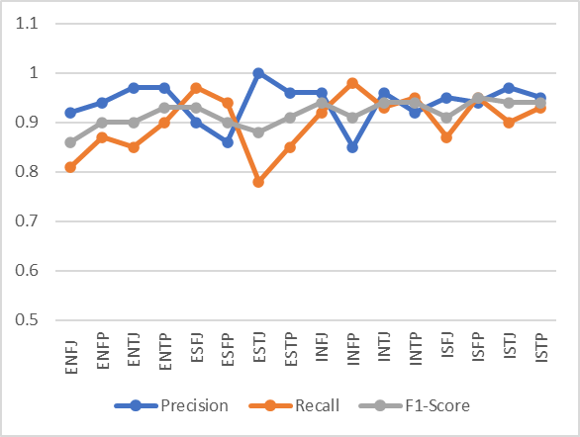
- Classification using LightGBM

Logistic Regression:

For classification problems, supervised machine learning algorithms like logistic regression are used to estimate the likelihood that an instance will belong to a certain class. It forecasts the result of a categorical dependent variable by estimating the probability for the specified class using a sigmoid function. A discrete or category value with probability values between 0 and 1 must be the result. Similar to linear regression, logistic regression predicts two maximum values, 0 and 1, using a logistic function with a "S" shape. This curve shows the probability of obesity or malignant cells in a mouse. Because it can provide probabilities and categorize newly discovered data using both continuous and discrete datasets, logistic regression is important [5]. The classification results are shown in Figure 5.

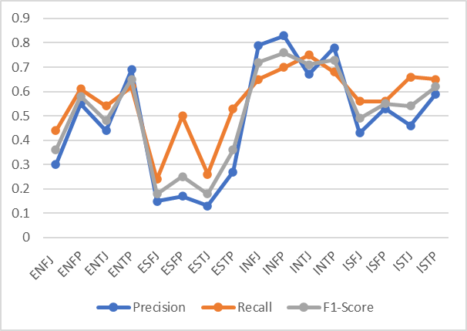

- Classification using Logistic Regression

The precision score value for all 16 traits is shown in Table 3 and is plotted in Fig 6 using all the classifiers.
Precision score comaprison table
Model | Naive Bayes | Random Forest | Logistic Regression | LightGBM
ENFJ | 0.29 | 0.39 | 0.36 | 0.97
ENFP | 0.63 | 0.58 | 0.77 | 0.99
ENTJ | 0.23 | 0.25 | 0.53 | 0.99
ENTP | 0.56 | 0.61 | 0.77 | 0.99
ESFJ | 0.09 | 0 | 0.26 | 0.9
ESFP | 0.09 | 0 | 0.16 | 0.94
ESTJ | 0 | 0 | 0.25 | 0.96
ESTP | 0.16 | 0.8 | 0.36 | 0.97
INFJ | 0.75 | 0.65 | 0.86 | 1
INFP | 0.71 | 0.63 | 0.89 | 0.98
INTJ | 0.49 | 0.59 | 0.81 | 0.99
INTP | 0.62 | 0.57 | 0.86 | 0.99
ISFJ | 0.3 | 0.46 | 0.54 | 1
ISFP | 0.21 | 0.47 | 0.65 | 0.99
ISTJ | 0.31 | 0.55 | 0.58 | 1
ISTP | 0.44 | 0.63 | 0.74 | 0.98

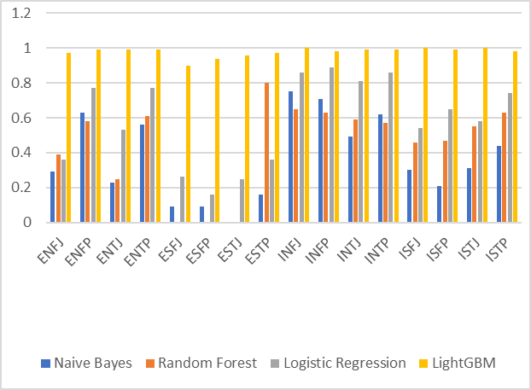
- Comparative analysis of Precision Score

Code
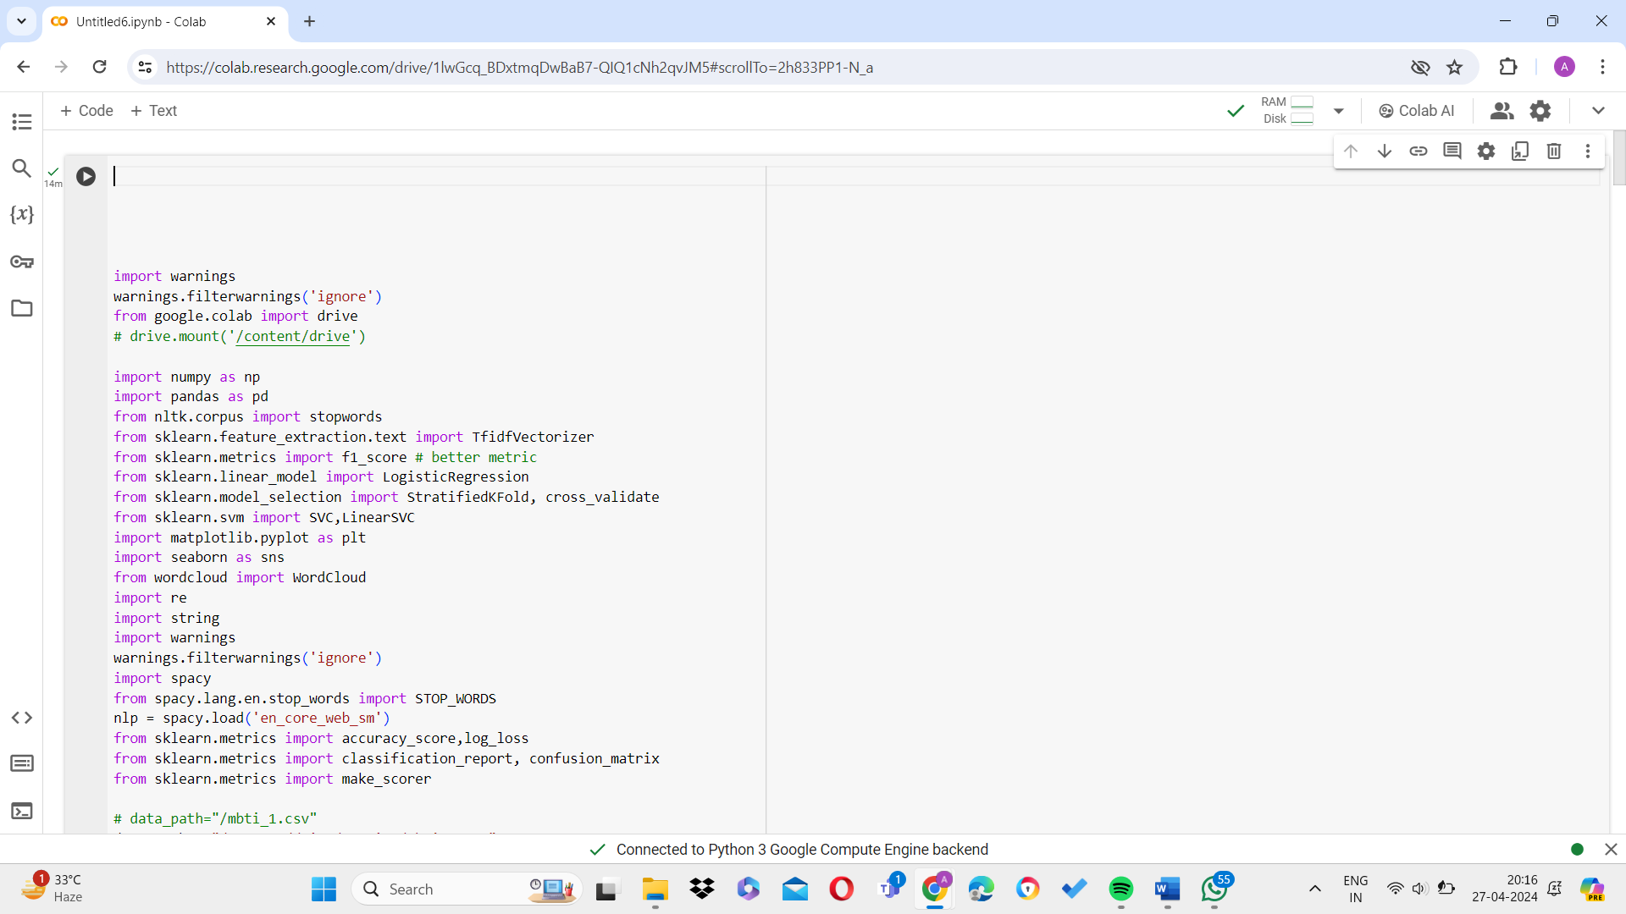
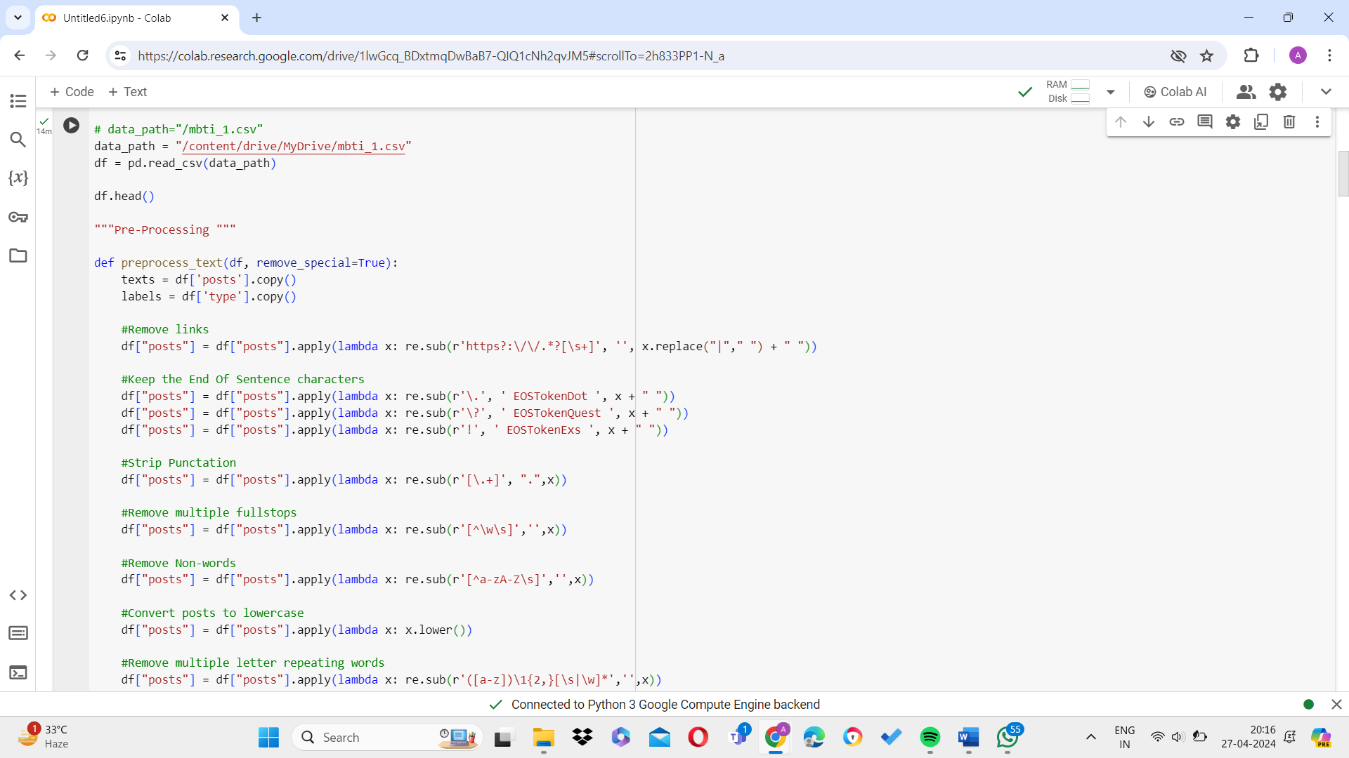
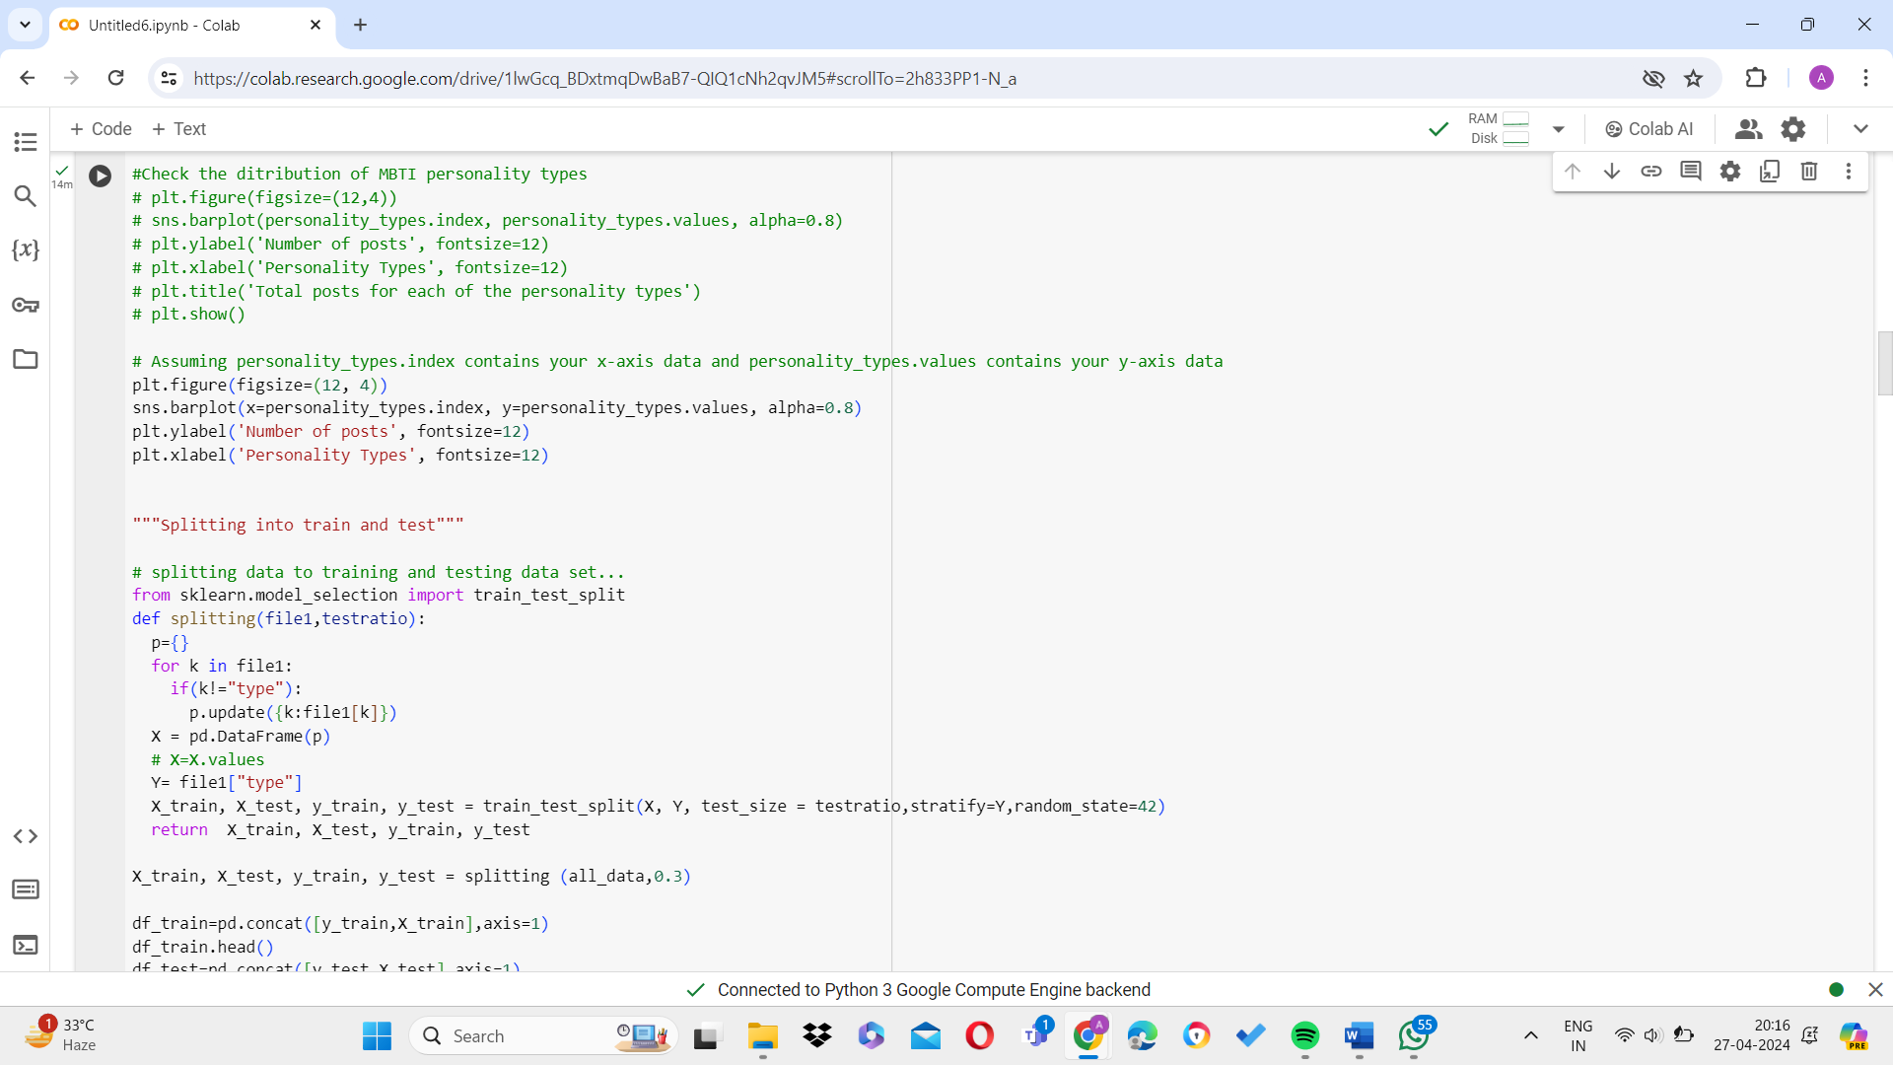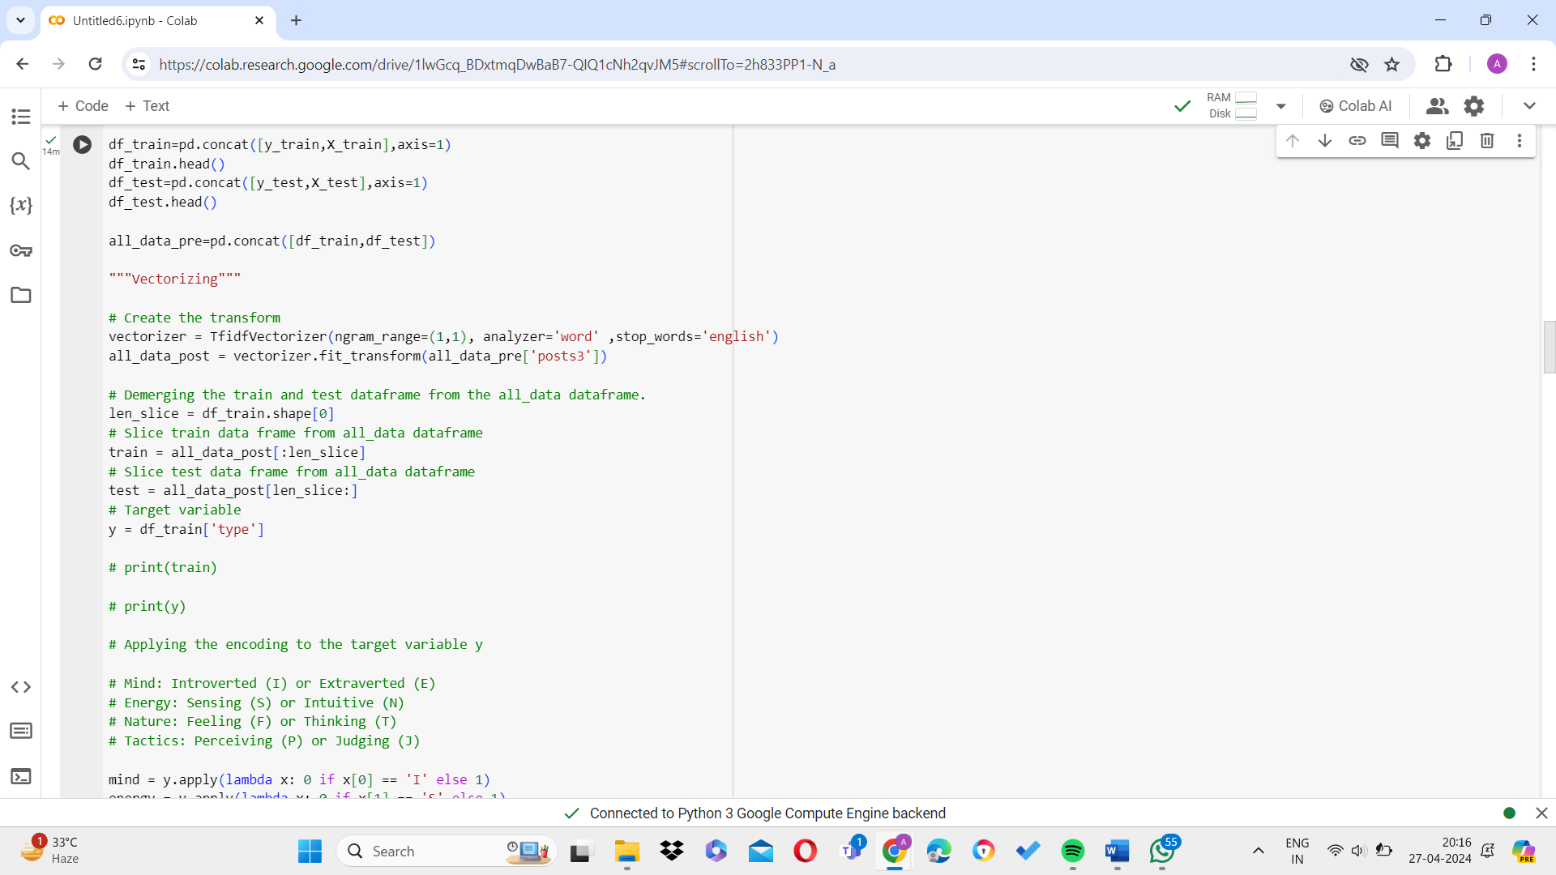
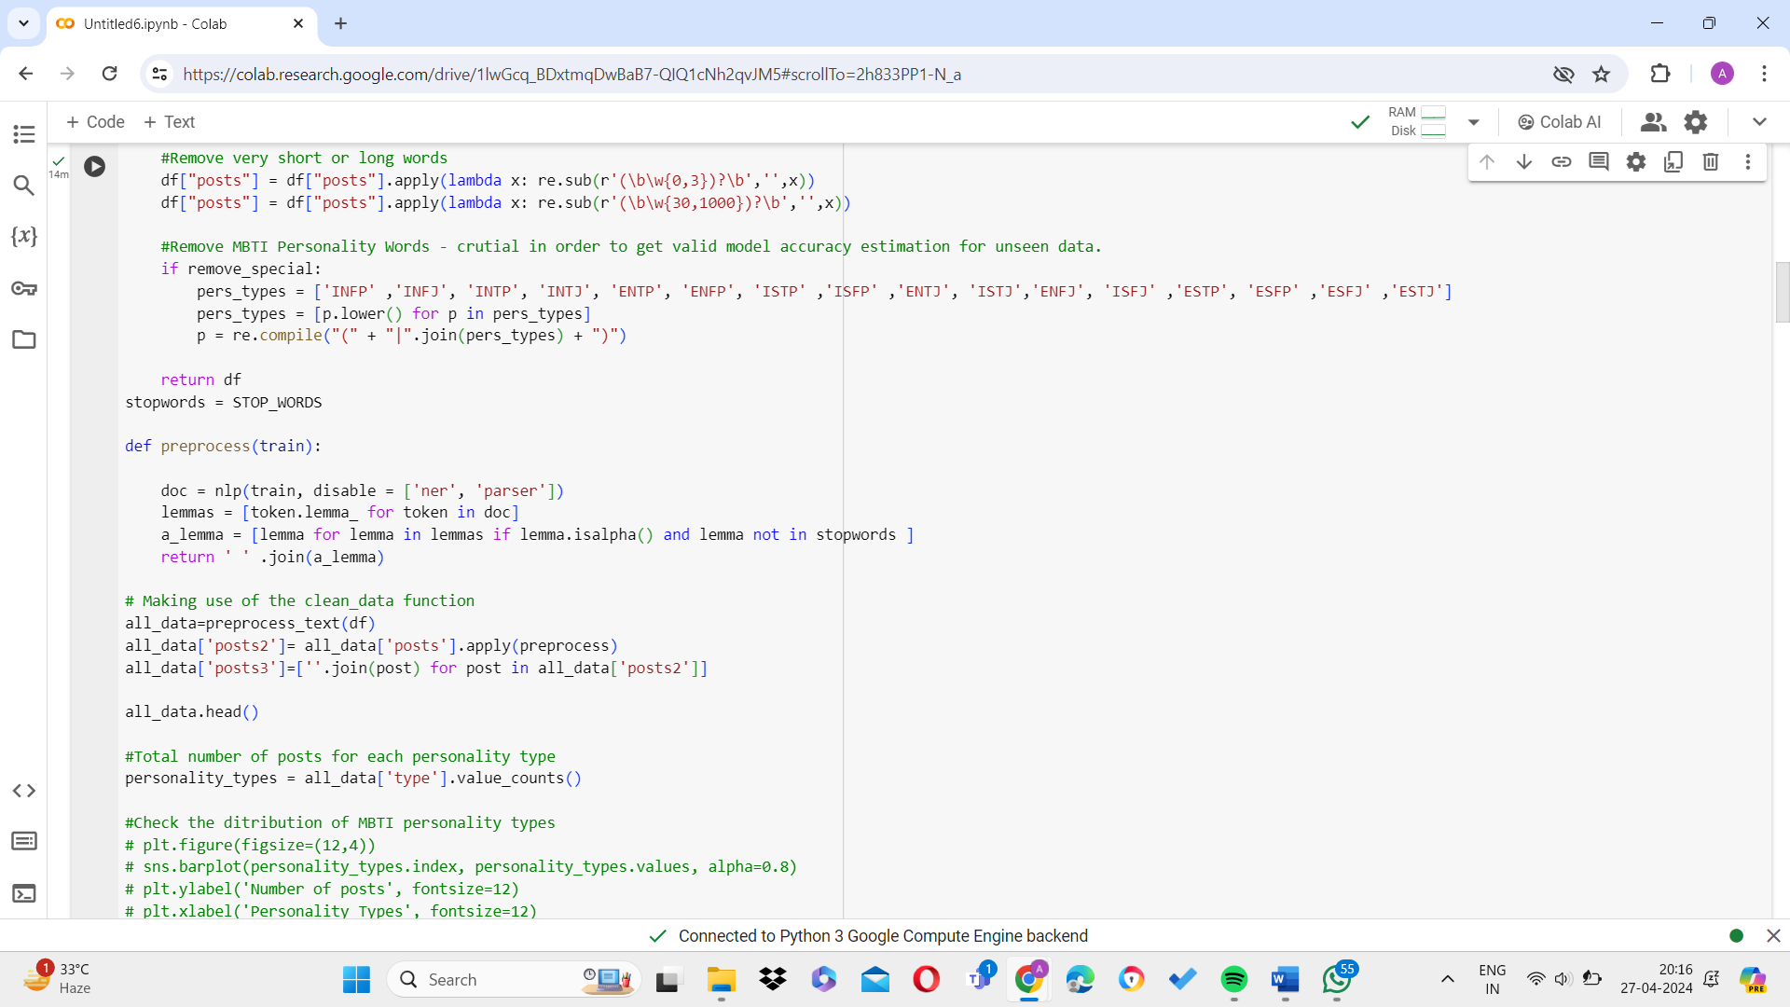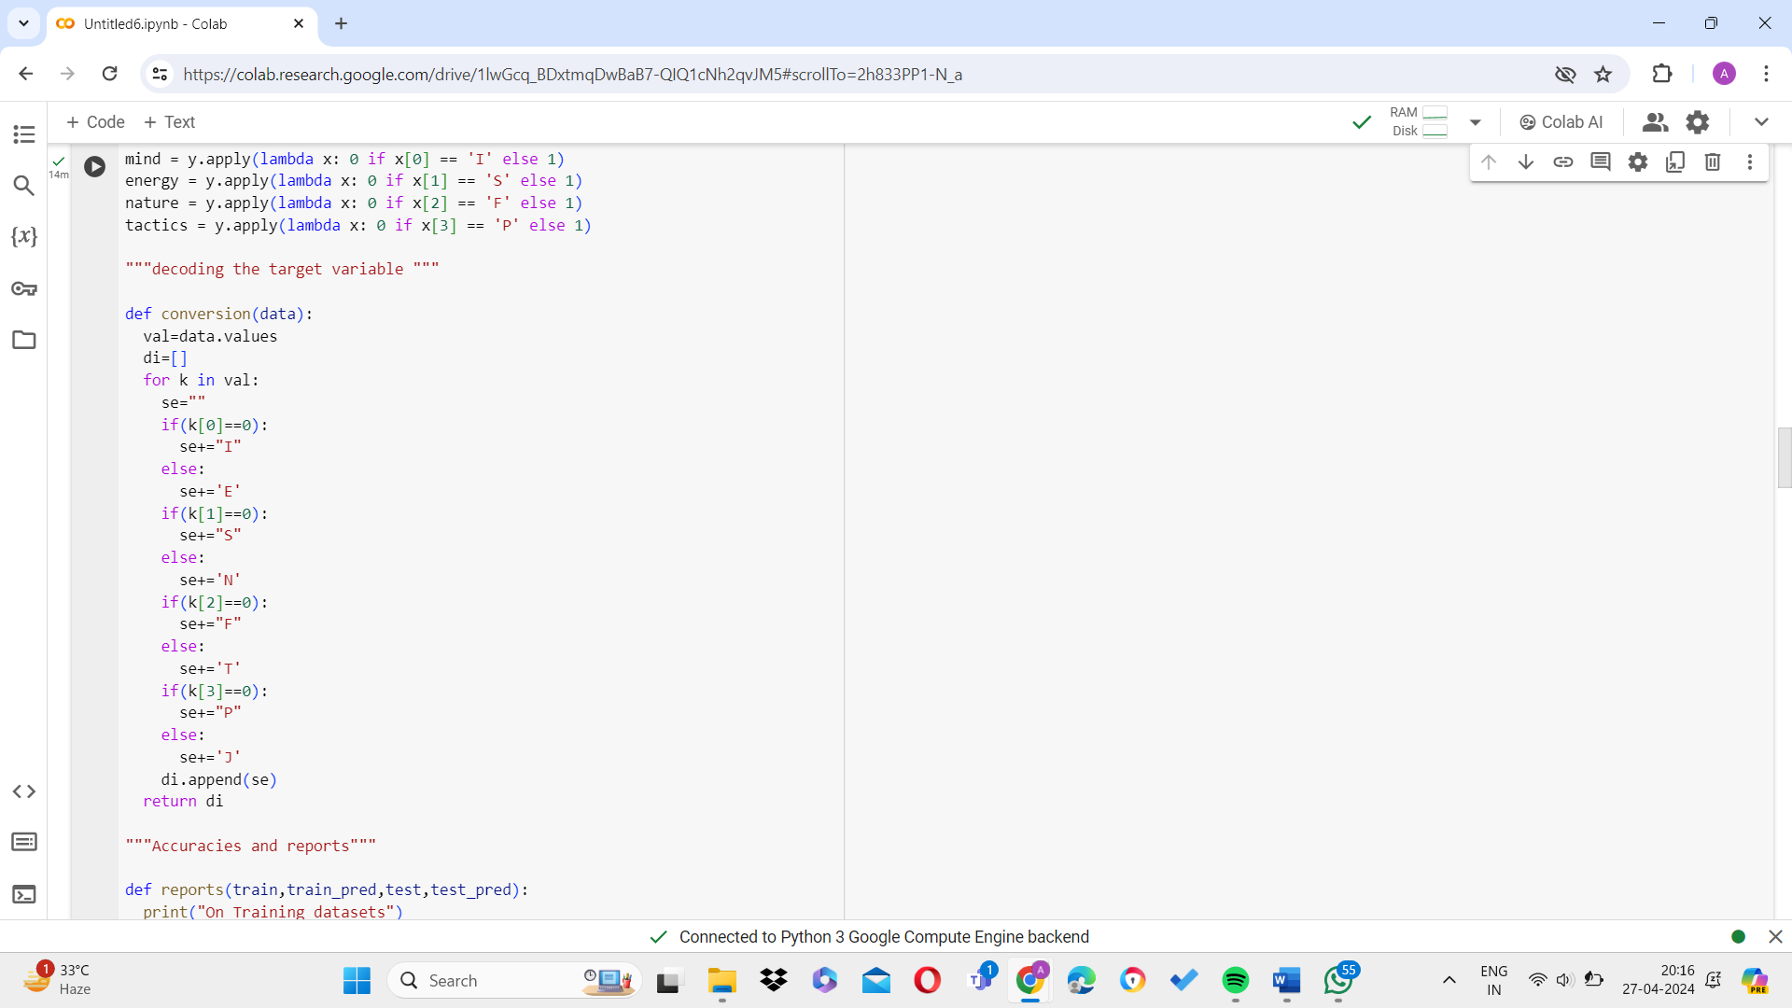

CHAPTER 4
RESULTS AND DISCUSSION
The proposed work is assessed using a number of performance metrics, including Accuracy, Sensitivity, Specificity, Precision, Negative Predicted value, and F1 Score.

Accuracy
This refers to the extent to which the system model is precise. This speaks to the degree of accuracy of the system model. It is, in general, the ratio of expected observations to total observations. The percentage of accurate forecasts to all prediction is known as accuracy. The accuracy is calculated using Eq1. The accuracy calculated are shown in Table 4.
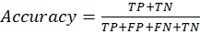 (1)

Tab;e :Accuracy values
Models Implemented | Training-Dataset Accuracy | Testing-Dataset Accuracy
LightGBM | 99% | 98.88%
Logistic Regression | 75.77% | 57.88%
Random Forest | 30.15 % | 28.19%
Multinomial Naive Bayes | 25.04% | 22.97%

From the table it can be concluded that The LightGBM and Logistic Regression models exhibit comparable accuracy levels on the training dataset. On the test dataset, the LightGBM and Logistic Regression models perform similarly, with same accuracy. In comparison to the other two models, the Multinomial Naive Bayes model performs less accurately on both the training and test datasets.

- Precision
How accurately a machine learning model predicts the future, is one indicator of the algorithm's efficacy. Precision is calculated by finding the values of True Positive and False Positive. The precision is calculated using Eq2. The accuracy calculated are shown in Table.
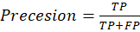 (2)
Precision values
Models Implemented | Training-Dataset Precision | Testing-Dataset Precision
LightGBM | 97.4% | 52%
Logistic Regression | 63% | 42%
Random Forest | 14 % | 15%
Multinomial Naive Bayes | 31% | 31%

- F1-Score
An assessment statistic for machine learning called the F1 score quantifies the accuracy of a model. It integrates a model's accuracy and recall ratings. The F1-score is calculated using Eq3. The F1-score calculated are shown in Table.
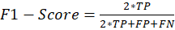 (3)
F1-Score values
Models Implemented | Training Dataset F1-score | Testing Dataset F1-score
LightGBM | 97.4% | 63%
Logistic Regression | 61% | 42%
Random Forest | 12.5 % | 11.3%
Multinomial Naive Bayes | 34.5% | 27.5%
D.Recall

Recall is dependent on True positive value and False Negative values. Recall is used to identify how good the model is to find the positive results. The recall value is higher if the model predicts the high positive samples. The Recall is calculated using Eq4. The Recall calculated are shown in Table.

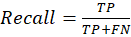 (4)

Recall Values
Models Implemented | Training-Dataset Recall | Testing-Dataset Recall
LightGBM | 96% | 74%
Logistic Regression | 56% | 51%
Random Forest | 20 % | 14%
Multinomial Naive Bayes | 16% | 14%

comparative analysis

The comparative analysis of all the techniques is shown in Table 8. The Table shows that the highest accuracy value (98.88%) achieved is using the LightGBM model.

Metrics | LightGBM | Logistic Regression | Random Forest | Multinomial Naive Bayes
Accuracy | 98.88% | 57.88% | 28.19% | 22.97%
Precision | 52% | 42% | 15% | 31%
F1-Score | 63% | 42% | 11.30% | 27.50%
Recal | 74% | 51% | 14% | 14%

Results
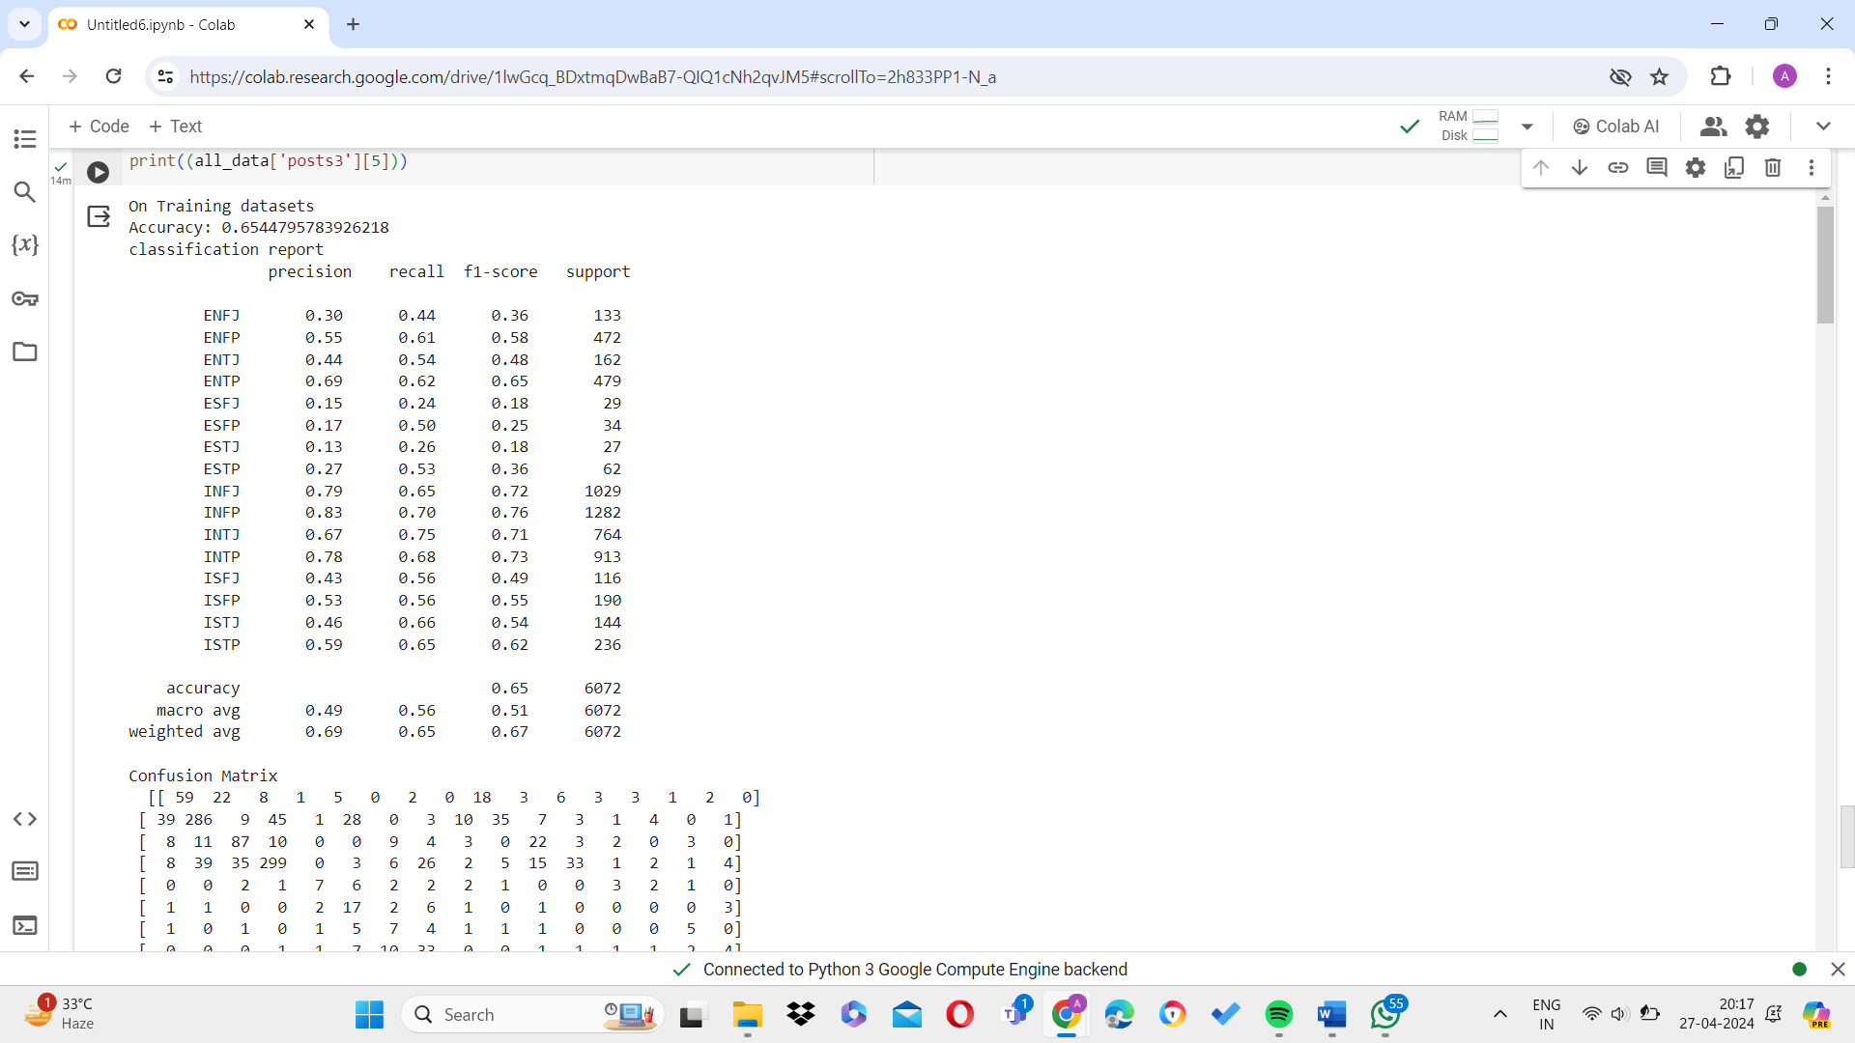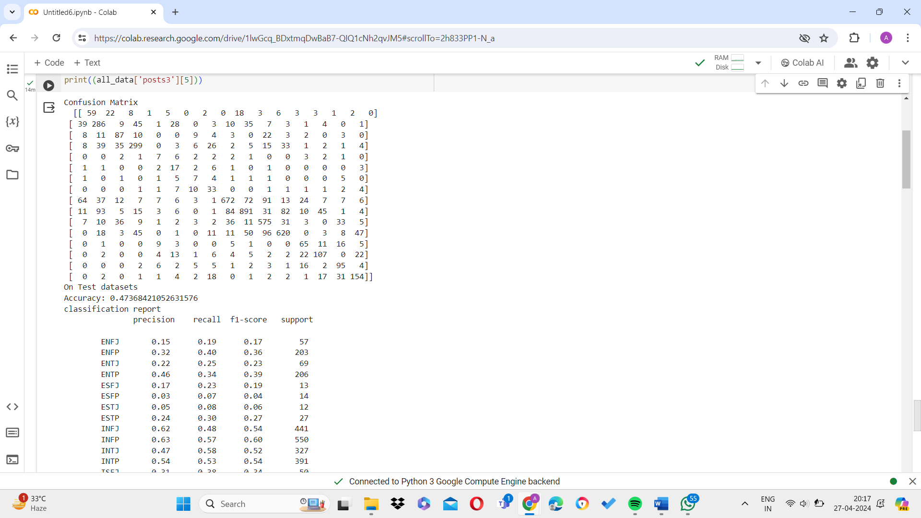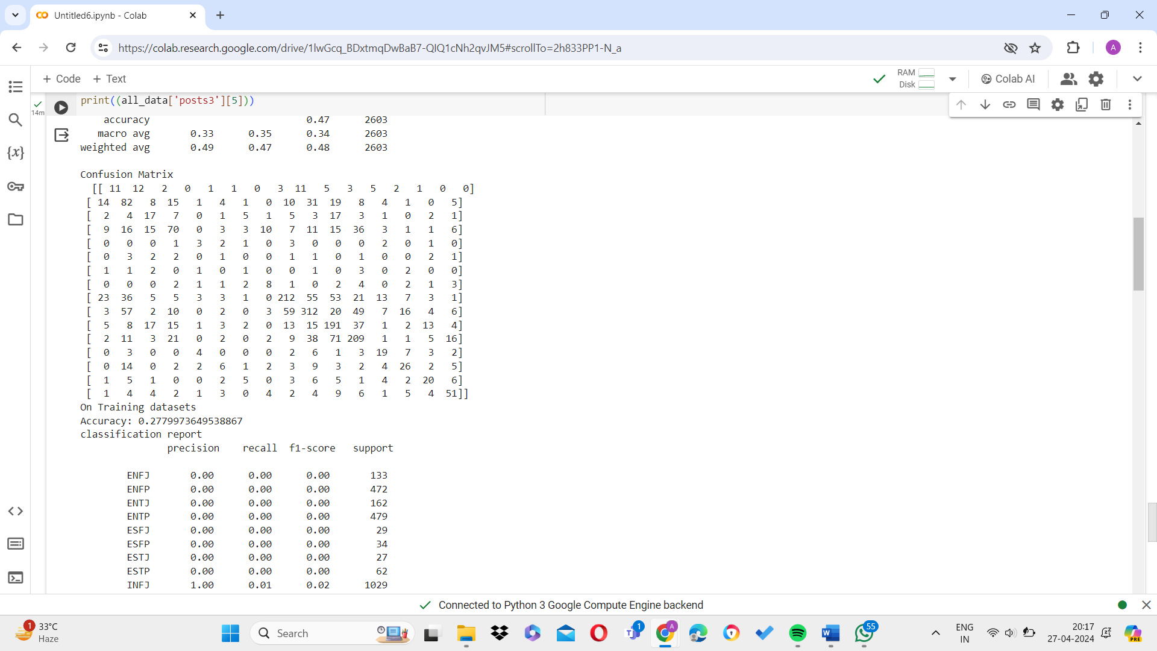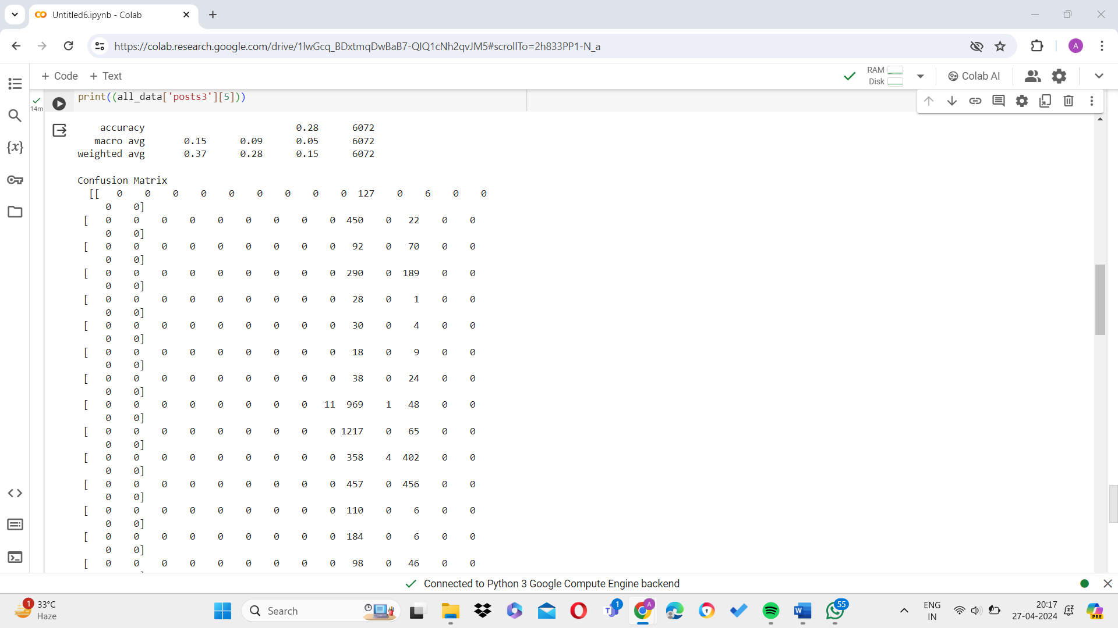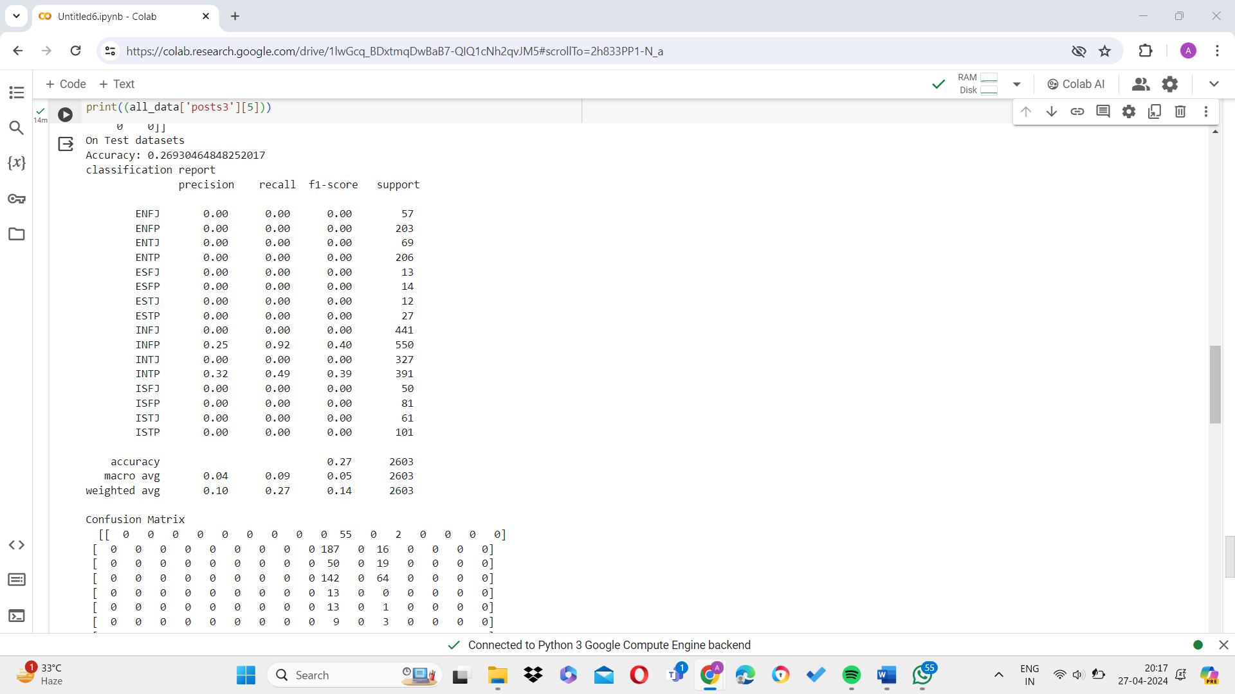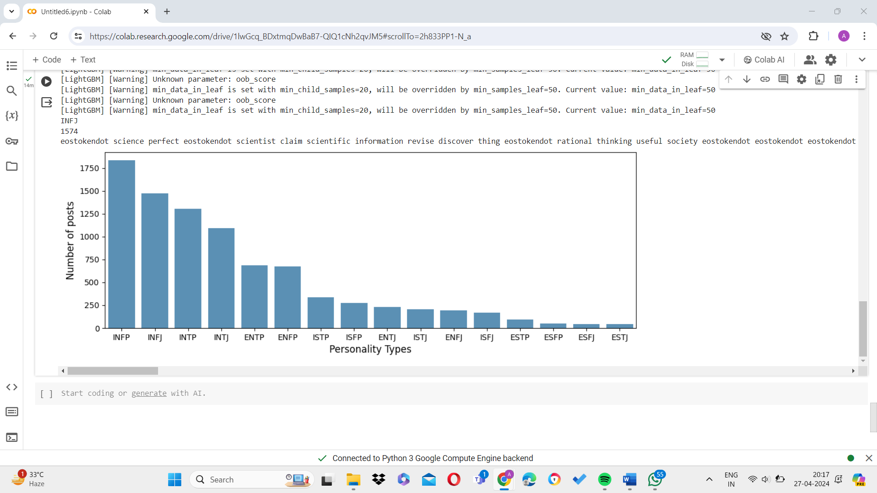

CHAPTER 5
CONCLUSION AND FUTURE SCOPE
CONCLUSION
In conclusion, this research represents a significant exploration into the promising realm of predicting personality using a diverse array of machine learning models. Our meticulous analysis and experimentation have shed light on the efficacy of various algorithms in capturing and interpreting the intricate facets of human personality. These findings underscore the vast potential of machine learning techniques in unraveling the complexities of individual traits, thus offering valuable insights into both psychology and behavioral science domains.

The results of our study particularly highlight the commendable accuracy demonstrated by LightGBM machine learning models in predicting personality traits. This underscores their practical utility as effective predictive tools in personality assessment tasks. However, there exists ample room for further investigation, especially on larger datasets. Future research endeavors could focus on scaling up the analysis to encompass more extensive and diverse datasets, allowing for more robust and generalizable conclusions.

FUTURE SCOPE
Moreover, the future scope of this research extends to the design and implementation of hybrid machine learning models. These models could leverage the strengths of multiple algorithms to enhance predictive performance and capture a broader range of personality nuances. By integrating various methodologies and approaches, such hybrid models have the potential to significantly advance the accuracy and reliability of personality prediction systems.

In essence, while this study marks an important step forward in the field of personality prediction, it also serves as a catalyst for continued exploration and innovation. Through ongoing research efforts, we can further refine our understanding and predictive capabilities regarding human personality, thereby opening new avenues for applications in various domains, including psychology, marketing, and personalized recommendation systems.

REFERENCES
- Murari Devakannan Kamalesh, Bharathi B, Personality prediction model for social media using machine learning Technique, Computers and Electrical Engineering, Volume 100,2022,107852,ISSN 0045-7906.
- Morgane Evin, Antonio Hidalgo-Munoz, Adolphe James Béquet, Fabien Moreau, Helène Tattegrain, Catherine Berthelon, Alexandra Fort, Christophe Jallais, Personality trait prediction by machine learning using physiological data and driving behavior, Machine Learning with Applications, Volume 9, 2022, 100353, ISSN 2666-8270,
- Samsuryadi, Rudi Kurniawan, Julian Supardi, Sukemi, Fatma Susilawati Mohamad, "A Framework for Determining the Big Five Personality Traits Using Machine Learning Classification through Graphology", Journal of Electrical and Computer Engineering, vol. 2023, Article ID 1249004, 15 pages, 2023. https://doi.org/10.1155/2023/1249004
- Christian, H., Suhartono, D., Chowanda, A. et al. Text based personality prediction from multiple social media data sources using pre-trained language model and model averaging. J Big Data 8, 68 (2021).
- M. M. Tadesse, H. Lin, B. Xu and L. Yang, "Personality Predictions Based on User Behaviour on the Facebook Social Media Platform," in IEEE Access, vol. 6, pp. 61959-61969, 2018, doi: 10.1109/ACCESS.2018.2876502.
- S. Dhelim, H. Ning, N. Aung, R. Huang and J. Ma, "Personality-Aware Product Recommendation System Based on User Interests Mining and Metapath Discovery," in IEEE Transactions on Computational Social Systems, vol. 8, no. 1, pp. 86-98, Feb. 2021, doi: 10.1109/TCSS.2020.3037040.
- Buettner, R. Predicting user behavior in electronic markets based on personality-mining in large online social networks. Electron Markets 27, 247–265 (2017).
- Ramezani, M., Feizi-Derakhshi, MR. & Balafar, MA. Text-based automatic personality prediction using KGrAt-Net: a knowledge graph attention network classifier. Sci Rep 12, 21453 (2022).
- Z. Tan, Y. Zhang, C. Zhang, R. Huang, P. Lei and X. Duan, "Research on The Text Emotion of Multinomial Naïve Bayes Integration Algorithm," 2019 IEEE 3rd Advanced Information Management, Communicates, Electronic and Automation Control Conference (IMCEC), Chongqing, China, 2019, pp. 107-111, doi: 10.1109/IMCEC46724.2019.8984049.
- Mohammad Savargiv, Behrooz Masoumi, Mohammad Reza Keyvanpour, "A New Random Forest Algorithm Based on Learning Automata", Computational Intelligence and Neuroscience, vol. 2021, Article ID 5572781, 19 pages, 2021.
- Woods RA, Hill PB. Myers Brigg. [Updated 2022 Sep 18]. In: StatPearls [Internet]. Treasure Island (FL): StatPearls Publishing; 2023 Jan-. Available

APPENDIX 1

